**L++: Life programming language**

Version 0.1

©2022, The University of Texas Southwestern Medical Center.

All rights reserved.

<https://kim-lab.org/>

# Table of Contents:

Table of Contents:

1 Introduction

2 Syntax

2.1 Basic Types

Numbers

Booleans

Molecules and Chemical Substances

Nucleotides

2.2 Control Flow

Conditional Statements

Looping Statements

for Loop

while Loop

2.3 Basic Operators and Keywords

Arithmetic Operators

Increment Operators

Logical Operators

Inequality Operators

Assignment Operator

Membership Operator

Indexing Operator

Binding Operator

Positional Operator

Length Operator

Arrow Operator

self Keyword

2.4 Advanced Molecular Structures

Reaction

Protein

Complex

Nucleic Acids

DNA

RNA

Pathway

Structural Components: Cytosol and Membrane

2.5 Imports

2.6 Parameters

Reactions

Reference

2.7 Prefixes and Units

Prefixes

Units

2.8 Built-in Functions

3 L++ Development Examples and Debugging

3.1 Overview

3.2 L++ Code Development Example

Designing E. coli chemotaxis

Implementing E. coli chemotaxis code

3.3 Debugging

Compilation Errors

“Biology” Errors

# 

## 1 **Introduction**

L++ is a powerful biology-oriented, high-level programming language. It is designed to abstract away microscopic interactions at a programmer’s level via familiar syntaxes while providing remarkable insight into intricate simulations when necessary.

The biological interpreter is written in C and C++, which parses and transcompiles L++ experimental code into Python to run efficient matrix-based, stoichiometric data calculations to run complex simulations.

This syntax tutorial aims to comprehensively introduce a variety of fundamental data types and structures virtually found in any simulation context, whether it’s high-level at an experimental level or low-level at the molecular level.

## 

## 2 **Syntax**

This chapter comprehensively covers all the types of syntaxes needed to get your first L++ program up and running to simulate experimental data. Many examples are provided along the way to help understand how and when each type of syntax is used.

Similar to other languages, L++ comments can be performed by //, for single line comments, or /* <multi-line comment> */ , for block-style comments.

L++ is a typeless language, meaning it doesn’t require data typing for more code efficiency. Data Types can be inferred, but types can be used to the programmer’s desire as well. In this case, both statements shown below would compile and run.

int x = 1;

x = 10;

In the example above, since x is initially declared as an integer (int), it can only be reassigned as another value of the same type. Reassigning it as any other data type will result in a compilation error. However, if x was never declared as an integer type, and rather just as

x = MoleculeA;

Its type depends on the context, and can therefore be reassigned to another experimental structure data type like so:

x = MoleculeB;

We’ll cover this more later in Assignment Operator.

### 2**.1 Basic Types**

Experiments run entirely on numbers and the entities those numbers correspond to. These types compose the fundamental structure of the data that drives L++ programs.

#### **Numbers**

Integers and floating point numbers (decimals) are both supported in L++ for the respective use cases. As the language is largely based on the context of which the syntax is used in, the type of number used in a specific use case matters. For example, in cases such as chemical coefficients, the molarity of a chemical substance, or specifying a timestep may allow for integers or floating points, but the number of pipettes being used in an experiment must be a whole number. Using the wrong number type depending on the context will result in a compilation error.

int a = 5;

int b = 2.0; // doesn’t work

float c = 10.0;

float d = 6; // works

Furthermore, units can follow numerical units to specify the experimental context. For example, the concentration of a solution would be given via molarity or molality. Here are a couple of examples; further references regarding units can be found in 2.7 Prefixes and Units.

R = 5nM;

B = 0.1nM;

Am = 500nM;

#### **Booleans**

Similar to any other language, booleans can be expressed through true or false, or numbers through 1 or 0. Nonzero numbers assigned to boolean types will be evaluated as true, while zero will be evaluated as false. They are commonly used within the context of control statements. Here are some examples:

bool is_true = true;

bool is_false = false;

x = true;

y = false;

#### **Molecules and Chemical Substances**

Molecules and chemical substances, both organic and inorganic, are the key components in simulating experiments. They’re one of the most common data types that will be found and used across L++ code, especially within higher level abstractions and more advanced L++ data structures that will be explained further in 2.4 Advanced Molecular Structures.

L++ supports chemical equation parsing, such as ; as such, the language supports coefficient-optional chemical formulas in order to declare specific molecular substances. The number of atoms of each element within a formula does not require a subscript; they can be directly typed out after the element. It’s implied that the leading number of a molecular formula will be its coefficient. Spaces between the coefficient, elements, and subscripts are optional, and will be omitted during the compilation of the code. Here are a couple examples of simple and complex chemical formulas:

| **Chemical Formula** | **L++** |
| --- | --- |
|  | H2O  2C6H12O6  (Cu(NH3)4)^2+ |

reaction CitrateCycle(acetyl_CoA + 3 NAD + FAD + ADP + Malate --> CoA_SH + 3 NADH + FADH2 + ATP + Malate)

Higher-level simulations often require more complex substances that have long, precise formulas. It would be tedious to manually type these formulas out everytime they were used, so L++ comes with an imported database of millions of common chemical formulas along with their chemical synonyms. As long as the synonym is supported, typing out the synonym directly in replacement of its chemical formula is also supported. If the program fails to compile with an error at a chemical synonym, it is most likely not yet supported by the language yet. No additional libraries are required to be imported in order to use this functionality. Here’s an example of ethanol combustion with chemical synonyms:

reaction combust(C2H5OH + 2 O2 --> 2 CO2 + 3 H2O);

reaction combust(ethanol + 2 oxygen --> 2 carbon dioxide + 3 water);

L++ determines the states of matter of any of the reactants and products based on the context of the simulation that most matches the real-world experiment. Therefore, states of matter don’t need to be explicitly declared in the reaction.

To create more scalable simulations that are capable of handling molecular interactions at a protein, or even organism level in the future, declaring millions of chemical substances manually for each biochemical interaction is beyond cumbersome. Though further discussed later in 2.4 Advanced Molecular Structures, it is worth prefacing that molecules and chemical substances are able to be encapsulated within more advanced data structures such as reactions, proteins, and pathways. The object-oriented approach enables significant scalability of the language in a variety of contexts.

#### **Nucleotides**

In genome-related experiments, L++ supports the expression of gene sequences in the form of DNA or RNA. On a basic level, the language supports the following syntax:

**A** - Adenine

**G** - Guanine

**C** - Cytosine

**T** - Thymine

**U** - Uracil

**N** - Any Nucleotide

In various biological scenarios nucleotide sequences are unknown at the beginning of the experiment; they are later determined by the context of the molecular interaction. As such, N can be used for positions in a specific gene sequence that can represent any nucleotide, which is later determined and replaced by one of A, G, C, T, U, during the simulation.

reaction RNAElongation(RNAP~Rna_{n} + c(NTP) + RNAP.ssDNA.N{n} --> RNAP~Rna_{n+1}, r=60.0);

### 2**.2 Control Flow**

As in any modern programming language, control flow is used to express and introduce rules within a program, such that certain pieces of code can be run for a number of times or only run under specific conditions.

#### Conditional Statements

If and else statements are used to control whether a piece of program should be executed under a certain condition. In many experimental contexts, molecular interactions should only occur if a specific concentration is reached, for example. The condition for an if statement must be wrapped within parentheses following the if keyword, and code used within if or else statements must be wrapped within curly brackets following the condition. if statements can stand alone, while else statements must be paired following an if statement.

specification

{

Ang = Membrane.phi;

Pos = Membrane.position;

cdist = 2.5e-5; // velocity from BergBrown_1972

crot = rand(0, 2 * pi); // constant for rotation

if (bRun)

{

Pos' = cdist;

Ang' = 0;

}

else

{

Pos' = cdist / 3;

Ang' = crot;

}

}

#### Looping Statements

In many experimental cases, repetitive tasks are necessary, such as preparing a series of beakers with a particular solution. L++ supports familiar looping structures such as the for loop and the while loop for code efficiency, similar to how they work in other languages.

##### for Loop

A for loop should be used when a piece of code is designed to run a fixed number of times. An example may be wanting to run an Electrophoresis experiment 15 times, plotting all the results on a graph. The syntax for the for loop is similar to their counterparts in languages like C++ and Java, with the following structure:

**for ([declaration]; [condition]; [increment])**

**{**

**[code block]**

**}**

1. **Declaration.** A variable assignment for a number.
2. **Condition.** Uses the previously declared variable and is often used with an inequality to state that while the condition holds true, the code within the for loop will execute.
3. **Increment.** The update of the declaration variable by a certain number, which can either take a positive or negative value.The declaration can “count down” by decrementing or “count up” by incrementing.

Here’s an example of how for loops can be used in L++ code. Note that the declaration, condition, and increment are all wrapped within parentheses, and each one is separated with a semicolon. Code to run in a loop must be wrapped within curly braces.

organism Ecoli;

for (i = 0; i < 3; i = i + 1)

{

Ecoli(rand(10), rand(10), 0) = 1;

}

This generates *E. coli* at a random location three times. The random x, y location is drawn from a uniform distribution from 0 to 10, inclusive. The third parameter represents the z coordinate, which is 0 as the *E. coli* are generated on a 2D plane.

##### while Loop

The while loop should be used when a piece of code is designed to run until a certain condition is met, rather than a fixed number of times. This may mean that the piece of code can never run, run once, run infinitely, or anything in between. Here's the structure:

**[declaration]**

**while ([condition])**

**{**

**[code block]**

**[increment]**

**}**

If the variable’s value still satisfies the condition of the while loop, the code block will run. Every time the code block is run, it is the programmer’s responsibility to increment or decrement the value of the variable at some point inside the code block. Although it’s most common to perform this increment at the end of the code block, it’s up to the programmer to decide how and where the variable’s value is updated.

A common mistake for many programmers is forgetting to increment or decrement the variable, resulting in running the code block infinitely (infinite loop). It is further important to note that the declaration for the variable used in the condition must occur before the while loop itself. Otherwise, the variable used in the condition is unable to know what value it is referencing. Here’s an example:

organism Ecoli;

int i = 0;

while (i < 3)

{

Ecoli(rand(10), rand(10), 0) = 1;

i++; // ++i works as well

}

These looping structures will become more useful upon further development, such as looping over an array of experimental structures in simulations involving numerous entities/trials.

### 2**.3 Basic Operators and Keywords**

Before we get into each set of operators, let’s go over some syntax typing conventions. Typically, code involving any operators with multiple operands should contain a space between the operator and the operands. Here’s an example:

float x = (5 + (3 * 1)) % 2

bool x_is_even = (x % 2) == 0;

Though these statements may compile and run successfully without the spaces, many L++ identifiers are often molecular substances that contain similar symbols in their names. These counterexamples may obstruct code readability:

**Ca+2_ion**

**2-Butanol**

#### Arithmetic Operators

L++ mathematical operators follow the same set of rules as any other programming language, in terms of associativity, commutative, distributivity, and order of operations. Order can be further enforced through the use of parentheses. The following operators are available:

| **Addition** | + |
| --- | --- |
| **Subtraction** | - |
| **Multiplication** | * |
| **Division** | / |
| **Modulo** | % |
| **Exponentiation** | **  e |

L++ includes new syntax for exponentiation. Similar to other languages, ** is still supported for statements like float x = 10**-5, representing . However, e can also be used to represent scientific notation with the format <base>e<power>. can also be expressed as float x = 10e-5.

#### Increment Operators

Syntactic sugar to increment or decrement a variable, either by 1 or by n, is supported.

Increments or decrements performed to a variable by 1 can be performed via ++ or --. Addition and subtraction are supported, meaning that you can either add 1 to a variable or subtract 1 from a variable with both of these operators, respectively. The order of placing these operators before or after a variable matters.

Preceding a variable with ++ or -- increments/decrements the variable’s value first, then evaluates the variable. Following a variable with ++ or -- evaluates the variable first, then increments/decrements the variable value. The difference in the order of these operations matters most when used in evaluating conditional statements and expressions. Here’s an example.

// Case 1:

x = 1;

y = x++; // x is 2, y is 1

// Case 2:

x = 1;

y = ++x; // x is 2, y is 2

Increments or decrements performed to a variable by n wil can be performed by +=, -=, *=, /= , or %=. In any case, the operation is performed on the variable, and the result of the operation will be assigned to the variable. Here’s the format:

**x [o]= n;**

**[o] - Operator.** Required. Can be one of +, -, *, /, or %.

#### Logical Operators

Logical operations result in booleans - either true or false. They are commonly used in program control flow, such as if-else statements to determine whether a piece of code should run based on a given condition.

| **Negation**  Inverts the boolean.  A = true;  !A = false; | ! |
| --- | --- |
| **Logical And**  True if and only if all operands are true.  A = true;  B = true;  C = false;  A && B = true;  A && B && C = false;  A && !C = true; | && |
| **Logical Or**  True if any one of the operands are true.  A = true;  B = false;  A || B = true;  !A || B = false; | || |

#### Inequality Operators

These are operators used to evaluate two numerical expressions, returning a single boolean value indicating whether the statement is true or not. The following inequalities are supported:

| **Greater than**  Returns true if the left hand side is greater than the right hand side. False otherwise.  x = 3 > 2; // True  // x is true | > |
| --- | --- |
| **Greater than or equal to**  Returns true if the left hand side is greater than or equal to the right hand side. False otherwise.  x = 2 >= 2; // True  y = 3 >= 2; // True  // x and y are true | >= |
| **Less than**  Returns true if the left hand side is less than the right hand side. False otherwise.  x = 0 < 1;  // x is true | < |
| **Less than or equal to**  Returns true if the left hand side is less than or equal to the right hand side. False otherwise.  x = 1 <= 2;  y = 2 <= 2;  // x and y are true | <= |
| **Equals**  Returns true if the left hand side is equal to the right hand side. False otherwise.  Does not assign a value to a variable.  x = 5 + 3 == 4 * 2;  // x is True | == |
| **Not equals**  Returns true if the left hand side is not equal to the right hand side. False otherwise.  x = 1 != 2;  // x is True | != |

These inequalities currently only support numerical comparisons. Operator overloading for customized comparison of experimental or user-created structures may be supported in future development.

#### **Assignment Operator**

Assignments are expressed through =, which is typically used to assign a value of any data type to a variable that can be manipulated later. The assignment operator has different meanings for each data type that performs the assignment. Here’s a list of each data type and the meaning of the assignment, along with several examples. Sections corresponding to each data type and structure will contain further examples and explanations.

1. **Basic Data Type**

Assignment to a value of the corresponding data type. Integers - int and float - should be assigned numerical values like 5.0 and 3, with an optional unit.

float x = 5.0;

1. **Parameter**

Assignment to a value accepted by the corresponding parameter.

kcat = 1.4;

1. **Molecular Substance**

Assignment to a numerical value to indicate a concentration.

h2o = 5nM;

glucose = 12uM;

1. **Experimental Structure**

Assignment to another experimental structure as a reference. The example below assumes p1 and p2 are the same type.

protein p1 = p2;

reaction r1 = p1; // does NOT work

1. **Reference Variable**

Assignment to alphanumeric strings depending on the parameter.

reference Ingalls_2013

{

title = “Mathematical Modelling in Systems Biology”;

page = ”151”;

figure = ”6.2”;

}

Reassignments of a variable that was initially, explicitly typed are only possible if the data type (before and after) matches. If a variable’s type was not stated upon declaration, then its type is inferred through the biological context of the simulation.

#### **Membership Operator**

The . operatoris important in accessing specific data stored inside these abstractions. It functions the same way as the dot operator in languages like Java, C, and C++. Let’s walk through an example of how it can be used:

**protein p**

**{**

**reaction r1(...);**

**reaction r2(...);**

**}**

A protein is instantiated in a code block, and the identifier for it is p. p is used to refer to this object in other places in the rest of the code. The protein takes in two reactions that describe p: r1 and r2. These reactions may be accessed using the membership operator, such as p.r1 and p.r2.

The membership operator is integral in high-level languages to describe simulations that become large quickly. Furthermore, it can be used to refer to specific structures located in imported files. Here’s an example:

import Divisome; // .lpp file name, contains complex ZRing structure

ZRing = Divisome.ZRing; // accessing complex declared in Divisome.lpp

FtsZ_Recruitment = ZRing.FtsZ_MembraneRecruitment; // accessing reaction declared in ZRing complex declaration

membrane Membrane;

Angle = Membrane.phi; // accessing intrinsic angle property of membrane variable

#### **Indexing Operator**

Square brackets, commonly used in array indexing in other languages, have a different connotation in L++. Though arrays will be developed in the near future, currently, indexing is primarily used in declaring the concentration of a substance at a given timestep. Square brackets can be used directly after an identifier of a substance, with the index being the absolute timestep (seconds by default), and the assignment being the concentration to set the substance at. Here’s the format:

**<identifier-name>[[t]] = [c][u]**

**[t] - Absolute Time.** Required. Integer or floating point value.

**[c] - Concentration.** Required. Integer or floating point value.

**[u] - Unit.** Optional. Any SI prefix + unit is supported.

How is this useful? Initial concentrations are an example of a situation where concentrations must be declared in any given experimental context. Another example may be keeping certain substances at a fixed concentration throughout an experiment. The syntax for timesteps are similar to slicing in Python: an optional : may be used to specify timestep ranges.

Molecule[0] = 5nM; // initial concentration at time 0

Molecule[:] = 5nM; // fixed concentration

Molecule[1:] = 5nM; // concentration from timestep 1 & onwards

Molecule [:3] = 5nM; // concentration up to 3rd last timestep

#### Binding Operator

Molecular interactions often lead to non-transient binding between the molecules. L++ uses ~ to represent that two biochemical structures are bound together. These structures are commonly proteins, domains, and the other molecular structures used to represent biochemical abstractions.

reaction SigmaFactorBinding(RNAPCore + SigmaFactor --> RNAPHolo, Kd=1e-7);

As previously mentioned, other L++ keywords like self can be used in conjunction with the binding operator. A common example, thus, is such that a protein, reaction, or any other structure referred to by self, can be bound to another declared biological experimental structure to express a merged state between yourself and another entity. Here’s an example:

reaction dsDNAUnwinding(self~dsDNA~RNA{n-10:n+10} --> self~ssDNA{n-10:n+10} + ssDNA{n-10:n+10}, r=1);

Here’s an example of the multi-binding property of the operator:

reaction 70S_Dissociation(30S~50S~mRNA~tRNA~RRF --> 30S + 50S + mRNA + tRNA + RRF, Kd=1e-9);

#### Positional Operator

When describing reactions involving macromolecules, precise referencing to specific locations of these structures may be needed. The positional operator enables positional specification of the building block along polymers, such as primary sequences of DNA, RNA and protein, and an individual protein in multimeric protein complexes. The {} operator is mainly used with DNA and RNA sequences in this format:

**<polymer-structure>[.<ss>]{<p1>[: <p2>]}**

**[.<ss>] - Substructure.** Optional. Accepts a single letter, which either represents a nucleotide base (A, G, C, T, U) or an amino acid residue (G, A, V, L, I, M, P, F, W, S, T, Y, N, C, Q, D, E, K, R, H).

For DNA/RNA, used to access nucleotide(s) at position/range. **<ss>** can take on any nucleotide base. Can access a stretch of nucleotides if a range is used instead of a number for the index. Example: DNA.A{243}

For proteins, used to access amino acid residue(s) at a position/range. **<ss>** can take on any amino acid residue. Example: Protein.H{354}

Usually, these represent too high of a resolution. Instead, use a general unspecified {n}th position sequence, which is N for nucleotides orX for amino acid residues. The unspecified sequence is only needed when referenced from other parts of the reaction.

**<position1>** - **Position 1**. Required. {<p1>} indicates a specific position p1, {:<p1>} indicates from the start to position p1, {<p1>:} indicates p1 to the end. The latter two formats cannot be used alongside [:<p2>].

**[: <p2>] - Position 2.** Optional. Specify inclusive range from position 1 to position 2.

Here’s an example of how {} can be used in the context of RNA translocation during transcription:

reaction Translocation(RNAPCore~ssDNA{n} --> RNAPCore~ssDNA{n+1}, r=10);

In the example above, the RNAPCore binding to the nucleotide at the nth position of ssDNA has been replaced to the nucleotide at the n+1th position along ssDNA, resulting in a translocation of RNAPCore on its bound ssDNA.

#### Length Operator

The _{} operator is used to access the length information, that is the quantity of building blocks, of polymers, such as DNA, RNA and protein, and multimeric protein complexes. Compared to the positional operator, the length operator does not concern the identity of the building blocks whatsoever. Here’s the format:

**<polymer-structure>_{<length>}**

**<length> - Length.** Required. Specifies the length of the polymer structure to be referenced.

Polymer elongation reaction is a type of reaction that can be efficiently described with the length operator. Here’s an example of RNA polymerase extending the nascent RNA using ssDNA as a template:

complex RNAP // self = RNAPCore~RNA~ssDNA

{

reaction Elongation(RNAP.RNA_{n} + c(NTP) + self.ssDNA.N{n} --> self.RNA_{n+1} + PPi + self.ssDNA.N{n}, r=60);

}

#### Arrow Operator

Many experimental structures involve chemical reactions that describe the relationship between reactants and products. The --> operator is used to not only separate the reactants from the products, but indicate the formation of products from reactants (in a forward reaction), and vice versa (in a reversible reaction). Every type of reaction uses the --> operator; only the constants passed into a reaction are necessary to differentiate chemical reaction types.

**reaction RxnName(reactants --> products, constants);**

#### self **Keyword**

When using these experimental structures, another common and helpful operator is the self keyword, which functions as a way to express a structure’s own identity. Other programming languages have their equivalent syntaxes: for C++ and Java, this is used for an object to refer to itself, and for Python, self does the same.

self can be used in a variety of contexts and along with other operators, such as the membership operator as well. In the same way that it is commonly used in other languages, self may be followed by a ., then by an identifier belonging to that entity. The identifier can be a variable (which would be called a “member variable”), or even a function that belongs to that entity (which would be called a “method”). L++ supports similar functionality; however, as many of these structures don’t contain methods of their own, self.<identifier-name> is commonly used to refer to specific variables declared within that structure. Here’s an example:

complex RNAP

{

// In this context, self = RNAPCore~ssDNA;

reaction Translocation(self.ssDNA{n} --> self.ssDNA{n+1}, r=10);

}

Note: we could technically use .N{n} to access the nucleotide at the position n, but the nucleotide information wouldn’t mean much in this translocation context.

Here, self.ssDNA assumes self is a complex that contains a single-stranded DNA component, which can either be explicitly or implicitly stated above. self.ssDNA{n} refers to position n of the ssDNA, which changes into self.ssDNA{n+1}, positionn+1 of the ssDNA. In a biological context, the reaction describes the 1 unit procession of the binding site along the ssDNA.

self can also be used independently. For example, a protein or a complex may react with other molecules, stated in a reaction. Therefore, self can be inside of a reaction statement enclosed within a complex block to refer to that complex itself. Here’s an example:

complex RhoComplex // Rho complex

{

reaction RNABinding(self + rut_repeat -> self~rut_repeat, Kd=1e-7);

}

### 2.4 Advanced Molecular Structures

As L++ emphasizes the importance of encapsulation and abstraction, the language aims to support higher-level molecular structures. This allows computational scientists to experiment with larger, more complex structures easily without needing to declare thousands of reactions on a microscopic level for every larger molecular entity, such as a protein complex. Here are a couple of fundamental, advanced structures that encapsulate some of the basic structures that have been covered.

#### Reaction

A chemical reaction is a key component of many chemical pathways, and are the foundations of the mechanisms in which chemical substances and organisms interact with one another. A reaction is a statement on its own, and describes the stoichiometric relationship between different biochemical entities. Here’s the basic syntax structure:

**reaction <identifier-name>[([e], [op])][;]**

**{**

**[e],**

**[op],**

**}**

**[e] - Chemical Equation.** Required. reactants --> products

**[op] - Other Parameters.** Optional. Includes constants, reaction rate, and more.

Reactions typically - though not enforced - contain the chemical equation as the first argument of the declaration. They also often have at least one reaction rate constant, which can be any of k, krev, kcat, KM, Ki, Ka, Kd, nH. A reaction’s type can be specified by using an appropriate set of constants. For instance, some parameters may be used alone (k or Kd), or conjugated (k and krev), or always meant to be coupled (Ki or Ka constants with Hill’s coefficient nH; kcat and KM).

Another parameter is the rate of reaction (r). Unless a specific unit is passed in, the default unit is ‘per second’. Explanations for each parameter and their corresponding units can be found in 2.6 Parameters.

Here are a couple of important notes on the reactions written in L++:

1. **Coefficients.** Coefficients for both reactants and products can be expressed through integers and floating point numbers for precise reaction stoichiometry or alphabets for generalization. They should precede the molecular substance it is describing, which can be represented as a chemical formula or a L++-supported chemical synonym.
2. **Directionality.** All reaction types contain the arrow operator pointing right without differentiation to indicate reversibility or inhibitory action. The type and directionality of the reaction only depends upon the parameters and the corresponding reaction model. For example, passing in the krev constant directly indicates a reversible reaction.

**reaction RxnName(reactants --> products, k and krev);**

**// Forwards reaction (k)**

**// Reversible reaction (krev)**

1. **Inhibition and Activation.** The regulatory effect of the reaction strictly follows the type of parameters passed in. For example, passing in the Ki constant in the regulatory reaction implies an inhibitory reaction of the regulator molecule on the target reaction.

**reaction RxnName(regulator --> reaction identifier, Ki and nH);**

**// Inhibitory reaction**

1. **Context Dependency.** For reactions enclosed within the protein or complex parentheses or code-blocks, the protein or complex (self) must be explicitly involved in the reaction or will act as an enzyme that facilitates the given reaction. In such enzymatic reactions, the enzyme concentration will be reflected onto the reaction rate.

L++ enables high-level abstractions of reactions without having to solely rely on biochemical algorithms, namely predefined reaction models, which are often designed to describe low-level biochemical reactions involving law of mass action and kinetic parameters for enzymatic functions and molecular interactions. To do so, there are several customization options for each reaction. Each option can be expressed with a keyword and a matching code block placed underneath the reaction. As many customization blocks can be used for a given reaction. Here’s the general syntax structure:

**reaction <identifier-name>(...);**

**[k]**

**{**

**<code-block>**

**}**

**[k] - Customization Keyword.** Optional. Any keywords from the following are allowed.

1. **specification.** Defines how the reaction statement should be executed without using a preset biochemical reaction model. Specifications are mathematical implementations of intended pathway designs, which are particularly useful when there’s insufficient biochemical implementation available. They are numerical rules used to determine the concentration of a chemical substance at any point of time in any given reaction. Relationships between the quantities of substances are created through assignments to mathematical expressions referencing other molecular substance concentrations.

reaction Glycolysis(G6P + 2 ADP + 2 NAD --> 2 pyruvate + 2 NADH + 2 ATP)

specification

{

float cg = 0.019M;

ATP' = (ADP / ATP) * cg;

ADP' = - ATP';

NADH' = ATP';

NAD' = - NADH';

G6P' = ATP' / 2;

pyruvate' = G6P' * 2;

}

ADP/ATP represents the ADP to ATP ratio at a given time, which is used to calculate the amount of ATP generated at every time step. In future developments, the rate of reaction for only one of the participating molecules can be described, and the rest will be automatically adjusted according to the stoichiometry of the reaction.

Notice the apostrophes ‘ following the naming of each reactant/product within the code block. This is used to describe the change of quantity in each simulation round, essentially a derivative where . Furthermore, the order of each equation in a specification{} matters, as each following equation may depend on the concentration of a previously described relationship. Each equation can be separated via a semicolon, as they are each independent statements.

1. **k_function / krev_function.** Allows customization of forward and reverse reaction rate calculations. The return values are used to update the molecular quantities of each reaction substrate.

reaction FtsZ_Recruitment(FtsA~(FtsZ_{n}) + FtsZ{in} --> FtsA~(FtsZ_{n+1})); // (n can be 0, as well)

k_function

{

return FtsA / max(1, MinC{in});

}

krev_function

{

return 0.5 + MinC;

}

In the example above, FtsZ_Recruitment uses two different functions to calculate the forward and reverse reaction rates.

#### Protein

Proteins are a specific class of macromolecules made of amino acid residues. They include enzymes that can catalyze certain reactions and structural/functional components of a cell. As proteins are often composed by the series of reactions they facilitate or are involved in, protein code blocks mainly contain relevant reaction declarations. If they simply encompass a single reaction, they can be declared similarly to how reactions are declared. Here’s the basic syntax structure:

**protein <identifier-name>[([r])][;]**

**[{**

**[r]**

**…**

**}]**

**[r] - Reaction.** Required. A protein involved in multiple reactions should be placed in a code-block rather than a single statement.

Here are several examples of accepted protein declaration statements:

protein CheB;

protein CheAm(CheB --> CheBP, k=0.05e9, krev=0.005);

protein CheR

{

reaction CheA_Methylation(CheA --> CheAm, kcat=1, KM=1e-10nM);

reaction CheAL_Methylation(CheAL --> CheAmL, kcat=1, KM=1e-10nM);

}

#### Complex

Proteins often form together to create stable protein complexes via non-covalent molecular interaction. This provides modular regulation of molecular processes. The complex syntax is largely interchangeable with protein. However, this data structure allows for shortcut complexation reactions for forming itself by specifying the subunits of the complex along with the kinetic parameter Kd.

protein RpoB, RpoC, RpoA, RpoZ;

complex RNAPCore(RpoB + RpoC + RpoA + RpoZ, Kd=1e-10);

complex RNAPHolo

{

reaction SigmaFactorBinding(RNAPCore + SigmaFactor, Kd=1e-7);

// ‘-—> self’ is assumed in the reaction argument

reaction PromotorBinding(self + dsDNA.promoter --> self~dsDNA.promoter);

}

Complexes inherit information from their different protein subunits to access their domains (for proteins) and motifs (for DNA and RNA). If no reaction is passed in, the reaction arrow (--> self) is made as default. Further development of L++ will enable additional, exclusive features that differentiate complexes further from proteins.

#### Nucleic Acids

Simulating cells and entire organisms can largely be expressed through genes. Though DNA is one of the major structures, L++ supports a variety of other genetic-related structures that help describe the functional behavior of these abstractions.

##### **DNA**

Deoxyribonucleic acid is a polymer - a naturally-occurring substance composed of macromolecules. In this case, the macromolecule refers to a nucleotide structure made of a nucleobase (Adenine (A), Guanine (G), Cytosine (C), Thymine (T)), a five-carbon sugar, and a phosphate group. Sequences of nucleotides are formed to create a singular strand, sometimes referred to as a template strand. DNA’s double-helix structure consists of the template strand and a complementary strand containing opposing nucleotides for each nucleotide in the template strand. Here’s a look at the structure of a sequence.

**Template Strand: CTGGCACNNN**

**Complementary Strand: GACCGTGNNN**

As seen in the example above, each strand can be expressed through the nucleobase that the nucleotide contains. Adenine and Thymine complement one another, while Cytosine and Guanine complement one another.

It’s important to note that many biological reactions can often change the state of a sequence. Sometimes, and quite commonly, certain nucleotides in sequence can’t be determined until after a specific reaction occurs. To support this idea, L++ uses N to express the idea of an unknown nucleotide. Here are two examples:

DNA Ori;

reaction OriBinding(DnaA + Ori --> DnaA~Ori, Kd=1e-9);

reaction OligoSynthesis(DNAP~ssDNA.N{n-10:n} + c(dNTP) --> DNAP~dsDNA, r=1000);

In the second example, N in ssDNA.N{n-10:n) refers to the stretch of 10 nucleotides.

##### RNA

Though genetic information is encoded within DNA, another nucleic acid is frequently found in biological contexts for other purposes. Ribonucleic acid is again a polymer and basically shares the same structure as DNA; however, Uracil (U) replaces Thymine (T) as one of its possible nucleobases. Furthermore, RNA is single-stranded. It carries genetic information to perform its main purposes, which involve facilitating the coding of proteins via translation, for example. The three main types of RNA are messenger (mRNA), transfer (tRNA), and ribosomal (rRNA). Here’s an example:

RNA tRNA;

complex AA_tRNA;

protein AA_tRNASynthetase(tRNA + AA --> AA_tRNA, kcat=1, KM=1e-9);

Similar to how amino acid sequences aren’t forced to be declared for proteins to describe their functions, L++ doesn’t require DNA or RNA to be assigned nucleotide sequences as long as they are assigned functions. Assignments to specific sequences and relevant features will come with development in the near future.

#### **Pathway**

Synonymous with the biological term, a pathway describes a series of biochemical interactions that lead to some product or effect within a particular context, most commonly in a cell. Since these interactions are most commonly described through a sequence of reactions, that’s exactly what the syntax of a L++ pathway looks like. Here’s an example:

pathway Transcription

{

pathway Initiation

{

SigmaFactorBinding = RNAPHolo.SigmaFactorBinding;

PromotorBinding = RNAPHolo.PromotorBinding;

SigmaFactorRelease = RNAP.SigmaFactorRelease;

}

pathway Elongation

{

dsDNAUnwinding = RNAP.Elongation.dsDNAUnwinding;

DNATranslocation = RNAP.Elongation.DNATranslocation;

RNAElongation = RNAP.Elongation.RNAElongation;

}

pathway Termination

{

IntrinsicTermination = RNAP.IntrinsicTermination;

}

SigmaFactor = 1500, RNAPCore = 3000, NTP[:] = 9mM;

}

Like previously stated, the syntax and rules for reactions in general can be applied here. One can assign and reassign chemical reactions declared within pathways to previously declared chemical reactions elsewhere in our code.

As seen above, pathways aren’t simply limited to containing reactions. They can contain a majority of other L++ experimental structures. Assignments for other structures, from reactions to domains to other pathways, can be made within pathways as well.

#### Structural Components: Cytosol and Membrane

Living matters are physically and functionally compartmentalized. The simplest organization is to have an aqueous compartment (cytosol) encapsulated by lipid bilayer (membrane), physically separated from the environment. L++ currently supports these two key structural components with cytosol and membrane.

Generally speaking, cytosol harbors large scale reactions driven by high abundance of molecules, such as metabolites. An example of a metabolic pathway occurring in the cytosol is glycolysis and protein biosynthesis.

On the other hand, membrane is often used to elevate local concentration of low abundance molecules to facilitate their intermolecular interactions. These structural code blocks can contain any combination of sequence of reactions, pathways, or other molecular abstractions. Here’s an example:

import GlucoseTransport;

import Glycolysis;

membrane CellMembrane

{

GlucoseTransporter = GlucoseTransport.GlucoseTransport;

cytosol Cytosol

{

Glycolysis = Glycolysis.Glycolysis;

G6P = 8.8mM, ATP = 9.6mM, ADP = 0.56mM, NADH = 8.3mM, NAD = 2.6mM;

}

}

Notice how a membrane also contains molecular structures that can be found within a cell (like cytosol). Just like how the cellular membrane wraps around cytosol to form the shape of a cell, the membrane in the code above acts as an outer scope, encapsulating the cytosol existing within the membrane.

By now, it is quite clear that there does not exist a clear top-down hierarchy of these molecular structures. With the complexity that comes in a biological cell, molecular structures can contain, and simultaneously be contained within, other molecular structures.

Syntax for structural components will substantially expand in the near future to accommodate high resolution spatial simulations.

### 2**.5 Imports**

As in any other programming language, common libraries can be imported in order to use specific data types and methods corresponding to those types that have already been implemented. Other L++ files can also be imported to access experimental structures and code located in other source files. Imports should typically be declared at the beginning of a program using import, so that the rest of the program can use any method/data structure part of the import. Here’s the syntax for importing a library/L++ file:

**import [i];**

**[i] - Import.** Required. Can either be a L++ library or filename. Filename doesn’t need to include .lpp.

Users do not need to worry about cyclic dependencies between files that contain the same imports. L++ supports a growing number of libraries containing built-in functions. Further references can be found in 2.8 Built-in Functions.

### 2**.6 Parameters**

As L++ supports a variety of experimental data structures, it’s imperative to note that different declarations take on a unique set of parameters. For example, the parameter temp (temperature) wouldn’t make sense for a pathway declaration. This section enumerates a complete list of possible parameters in L++ and their respective meanings.

#### Reactions

1. **Equation**. Accepts a chemical equation composed of reactants, products, and the relationship between them via an arrow operator. The argument eq = can be explicitly written, or the equation can directly and implicitly be passed in. Typically the first parameter in a reaction declaration statement.

**eq = <reactants> --> <products>**

The type of reaction is determined by the type of reaction parameters provided with the equation.

1. **Reaction Parameters.** Accepts any one of the following reaction constants: k, krev, kcat, KM, Ki, Ka, Kd, nH or r. Depending on the reaction type, multiple reaction constants may be passed in. Here are several constants and their syntax counterparts:

| k | **Forward reaction rate constant.** Describes the proportional relationship between the concentrations of reactants and the rate of forward reaction. Used in elementary chemical reactions. |
| --- | --- |
| krev | **Reverse reaction rate constant.** Describes the proportional relationship between changes of the concentrations of reactants and the rate of reverse reaction. Used in elementary chemical reactions. |
| kcat | **Catalytic conversion constant** of substrate into product. Used together with KM in Michaelis Menten kinetics. |
| KM | **Michaelis Constant.** Describes the amount of substrate needed for the enzyme to obtain ½ of the maximum rate of reaction. Used together with kcat in Michaelis Menten kinetics. |
| Ki | **Inhibition Constant.** Describes the concentration of an inhibitor required in order for ligands to occupy ½ of the receptor binding sites. Used with nH. |
| Ks | **Half-saturation Constant.** Describes the concentration of a substrate required in order to half the maximal reaction rate. Used with nH. (Note: Ks may appear as Ka in early version of L++) |
| nH | **Hill Coefficient.** Describes the degree of cooperativity in a binding process. Used together with Ki or Ks. |
| Kd | **Dissociation Constant.** A type of equilibrium constant that describes the propensity of a molecular complex to separate reversibly into smaller components. |
| r | **Reaction Rate.** Directly used for the rate of reaction, instead of using the law of mass action. Unless a specific unit follows, the default unit is per second. Used alone. |

#### **Reference**

Descriptions of biological pathways and experimental contexts can often be attributed to alternate authors and scientists. Instead of commenting, L++ directly supports reference{} to encourage programmers to credit sources when referencing their work. Here’s an example.

reference ThomasSteitz_2008

{

title = "A structural understanding of the dynamic ribosome machine";

doi = "https://doi.org/10.1038/nrm2352";

}

The code block takes in the following, expanding list of parameters:

1. **Title** - Accepts a string that names the title of the reference.

**title = “[s]”;**

**[s] - Source Name.** Required.

1. **DOI - Digital Object Identifier.** A unique alphanumeric string that provides a persistent link to the original source on the internet.

**doi = “[d]10.[o]/[p]”;**

**[d] - URL Prefix.** Optional. Protocol and resource names from https://doi.org/.

**[o] - Organization Number.** Required. Four-Digit Identifier assigned to organizations.

**[p] - Publisher String.** Required. Alphanumeric string assigned by publisher.

1. **Date** - Accepts an alphanumeric string given in any of the following formats:

**date = “[Month] [Date], [Year]”;**

**date = “[MMDDYY]”;**

**[Month] - Month.** Required. Alphabetic string for month.

**[Day] - Day.** Required. One or Two-Digit Integer value.

**[Year] - Year.** Required. Four-Digit Integer.

**[MMDDYY] - 6 Digit Datetime.** Required. Integer representation for **MM** (month), **DD** (day), **YY** (last two digits of year).

1. **Volume** - Accepts a string corresponding to the volume of the reference. Does not require a specific format.

**vol = “[v]”;**

**[v] - Volume.** Required. Alphanumeric String.

1. **Journal** - Accepts an alphanumeric string naming the reference’s journal name. Does not require a specific format.

**journal = “[k]”**

**[j] - Journal Name.** Required. Alphanumeric String.

1. **Page** - Accepts an integer numeric value corresponding to the page number in the reference.

**page = [p];**

**[p] - Page Number.** Alphanumeric String.

1. **Figure -** Accepts an integer or floating point numeric value corresponding to the figure number in the reference. Can include an optional delimiter to indicate a subfigure.

**figure = [f].[s];**

**[f] - Figure Number.** Required. Integer or floating point value.

**[s] - Subfigure.** Optional. Alphanumeric String.

1. **Equation -** Accepts an integer or floating point numeric value corresponding to the equation number in the reference.

**equation = [e];**

**[e] - Equation Number.** Required. Alphanumeric String.

Any number of parameters may be used in any given reference block. Parameters are optional and can be repeated. Each parameter assignment is a statement, so they must be separated by semicolons.

### 2**.7 Prefixes and Units**

In many experimental contexts, units are used to describe specific characteristics such as molarity and volume. L++ implements a two-part format of expressing a prefix and a unit.

##### **Prefixes**

Prefixes are the optional, first half of a unit. Our prefix system matches that of traditional SI Unit prefixes. The following prefixes are supported. Note that the capitalization of the prefix matters.

| **Yotta (Y)** - 10^24  **Zetta (Z)** - 10^21  **Exa (E)** - 10^18  **Peta (P)** - 10^15  **Tera (T)** - 10^12  **Giga (G)** - 10^9  **Mega (M)** - 10^6  **Kilo (k)** - 10^3  **Hector (h)** - 10^2  **Deka (da)** - 10^1 | **Deci (d)** - 10^-1  **Centi (c)** - 10^-2  **Milli (m)** - 10^-3  **Micro (u)** - 10^-6  **Nano (n)** - 10^-9  **Pico (p)** - 10^-12  **Femto (f)** - 10^-15  **Atto (a)** - 10^-18  **Zepto (z)** - 10^-21  **Yocto (y)** - 10^-24 |
| --- | --- |

##### **Units**

Prefixes are the required, second half of a unit. The following units are supported. Note that the capitalization of the units matters. Identifiers and parameters named after the units below will result in a syntax compiler error.

| **Volume** | **Liter** - L |
| --- | --- |
| **Time** | **Second** - sec  **Minute** - min  **Hours** - hr |
| **Mass** | **Gram** - g |
| **Temperature** | **Celsius** - C  **Fahrenheit** - F  **Kelvin** - K |
| **Electricity** | **Volt** - V  **Ampere** - A |
| **Concentration** | **Mole** - mol  **Molarity** - M  **Molality** - m |
| **Brightness** | **Candela** - cd |
| **Speed** | **RPM** - rpm  **G-Force** - G |

### 2**.8 Built-in Functions**

L++ supports an expanding list of importable, common functions and methods designed around our experimental data structures. Here’s a breakdown of the list of currently supported built-in functions. Future development involves creating libraries for each category of functions and importing the desired libraries.

**max(value1, value2)**

Returns maximum between two values, and either if they are equal. Both parameters accept numerical values (integer or floating point).

**min(value1, value2)**

Returns minimum between two values, and either if they are equal. Both parameters accept numerical values (integer or floating point).

**rand(value1, value2)**

Returns a random value in the range value1 to value2, inclusively. Performed through a uniformly distributed random function.

**normal(value1, value2)**

Returns a random value in the range value1 to value2, inclusively. Performed through a normally (gaussian) distributed random function.

**log(value [,base])**

Returns the logarithm of value to base e, or if a second parameter is passed in, returns the logarithm of value to a specified base.

**c([base sequence])**

Returns the complementary nucleotide sequence to the input nucleic acid sequence.

**rc([base sequence])**

Returns the reverse complementary nucleotide sequence to the input nucleic acid sequence.

## 

## 3 L++ Development Examples and Debugging

Most of L++ code development is spent on the design and debugging process. The actual code-writing is made as easy and general as possible to clearly express biological processes.

### 3.1 Overview

The first step of L++ development is determining the goal of the biological process to simulate. Input and output and/or the behavior of biological processes must be laid out in terms of analog signals using quantities of molecular species or their states.

Then, the actual code for the biological process can be implemented. The system behavior is ideally accomplished solely using biochemical algorithms. However, it is often challenging due to many unknown parameters of elementary chemical reactions taking place in a system. Implementations often employ some level of abstraction and model reduction, bypassing the need for every single parameter in the elementary chemical reactions in the system at the expense of the perturbability of those parameters. L++ syntax specification and k_function are wonderful abstractions created for these purposes.

Fortunately, there are many cellular pathways, such as *E. coli* chemotaxis, where molecular mechanisms have already been identified and reduced mathematical models have been worked out. We’ll use it as an example to highlight L++ code writing.

### 3.2 L++ Code Development Example

#### Designing *E. coli* chemotaxis

We assume that *E. coli* is situated where a chemical gradient is relatively small across its own body, such that it’s difficult to differentiate the chemical concentration at one end against the other. This contrasts much bigger cells like mammalian cells (greater than 10 times larger in body length), which have a higher likelihood of sensing and responding to their local environments at one end of the cell in a polarized fashion.

Instead, *E. coli* relies on its ability to sense the change in chemical concentration at a particular position. *E. coli* compares the current concentration level to the previous level to decide whether it moves straight or rotates itself using counter-clockwise and clockwise flagellar motor rotation. For example, when there exists a large elevation in chemical concentration, *E. coli* moves in a straight line with more assurance. Then, regardless of the abundance of the chemical, constant chemical concentration in the environment results in *E. coli*’s tumbling. This adaptive behavior ensures E. coli to move up and down the gradient of chemical concentration.

#### Implementing *E. coli* chemotaxis code

How can one implement this using a biochemical algorithm? Many molecular circuit designs may be considered and developed, which then need to be expressed in an appropriate language like L++. The following briefly explores a subsection from the Ingalls 2013 textbook, followed by how one would write out a corresponding L++ program.

The known molecular pathway can be described as follows:

*E. coli cells use a signalling pathway to convert their measurements into an exploration strategy. This pathway, shown in Figure 6.12, transduces a signal from the transmembrane receptors (which bind attractant or repellent) to the flagellar motor. The receptors are complexed with a kinase called CheA (‘Che’ for chemotaxis). CheA phosphorylates the cytosolic protein CheY, which, when activated, binds to the flagellar motor and induces tumbling. Binding of chemoattractant to the receptor inhibits CheA activity; this reduces levels of active CheY, and thus inhibits tumbling. Binding of repellent activates CheA and so has the opposite effect.*

*The pathway’s ability to adapt to new environments is conferred by an added layer of complexity. On each receptor there are several sites that can bind methyl groups. Methylation is catalysed by an enzyme called CheR. Another enzyme, CheB, demethylates the receptors. Receptor methylation enhances CheA activity, so methylation induces tumbling. A feedback loop is provided by an additional catalytic function of CheA—it activates CheB (again by phosphorylation). This is a negative feedback on CheA activity. (When CheA is, for example, inhibited, CheB activity is reduced, which leads to more receptor methylation and hence increased CheA activity.) This feedback acts on a slower time-scale than the primary response, and causes the system to return to its nominal level of CheA activity (and thus motor behaviour) after a change in ligand concentration. This is the mechanism of adaptation.*

Ingalls 2013, page 161

A reduced reaction network of the above text can be described with the following pathway:

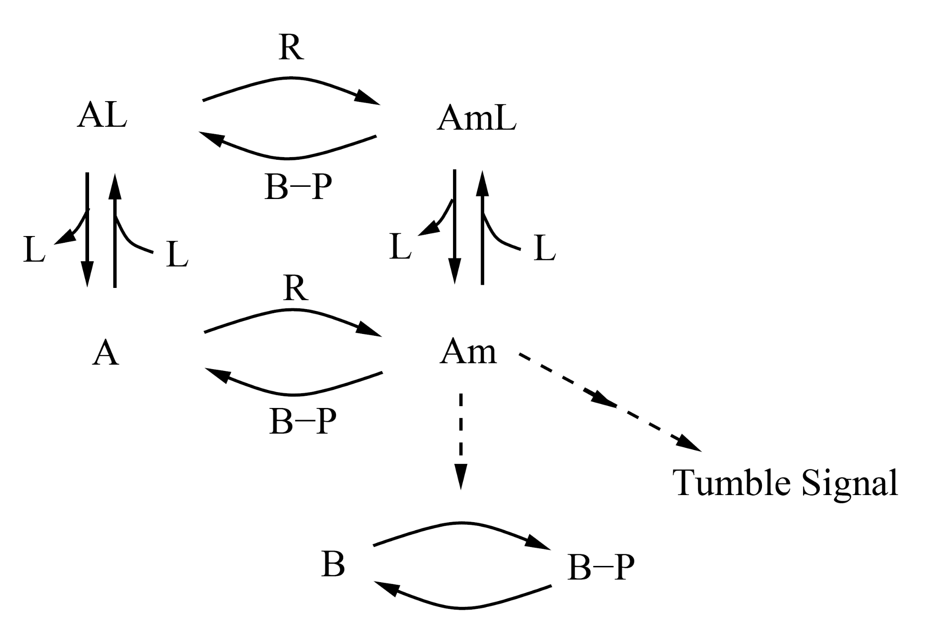

Ingalls 2013, page 163

The model equation is described as follows:

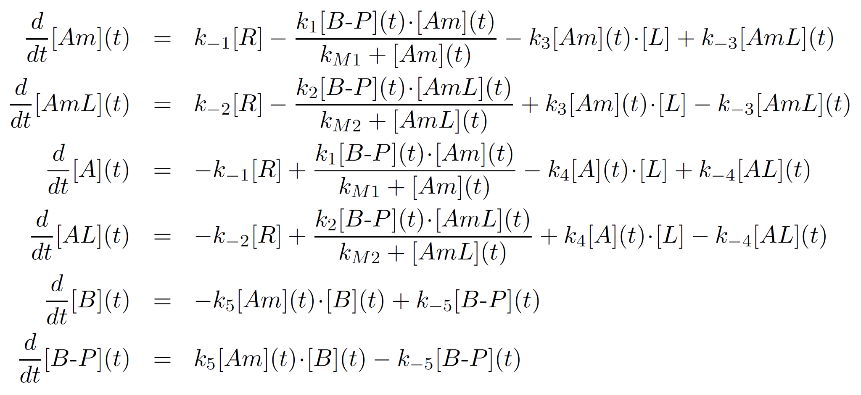

Ingalls 2013, page 162

Together with the reaction parameters obtained from the reference, one can simply describe the biochemical reactions using L++ as follows:

protein R

{

reaction R1(A --> Am, kcat=1, KM=1e-10nM);

reaction R2(AL --> AmL, kcat=1, kM=1e-10nM);

}

protein BP

{

reaction R1(Am --> A, kcat=200, KM=1nM);

reaction R2(AmL --> AL, kcat=1, KM=1nM);

}

protein Am

{

reaction R(B --> BP, k=0.05e9, krev=0.005);

}

reaction R1(Am + L --> AmL, k=1e9, krev=1);

reaction R2(A + L --> AL, k=1e9, krev=1);

R = 5nM, B = 0.1nM, A = 500nM;

L[0:100] = 20nM, L[100:200] = 40nM, L[200:300] = 80nM;

No complex mathematical relationships are needed. Just straightforward, text-based programming using biologically intuitive syntax is all there is.

### 3.3 Debugging

Debugging is a key refinement and optimization step to match a desired system design at all levels of life programming. Just like any other language, programming in L++ is an iterative cycle! It’s rare to get a program to simulate successfully the first time around. The process involves writing code, executing a program, identifying errors (if existing), and debugging those errors.

Similar to syntax and logical errors when programming in other languages, there may be different types of bugs to debug in your L++ code.

#### Compilation Errors

A compilation error occurs when parsing a source file and before a simulation is run. The L++ interpreter performs a variety of checks to ensure the lexical contents of source file are error-free before attempting to run its simulation; otherwise, a compilation error is thrown. When a compilation error occurs, an error message and the location of the buggy code may be specified. These errors are often attributed to syntax errors, such as (but not limited to):

1. Unsupported keywords and identifiers.
2. Misspelled keywords and identifiers.
3. Missing punctuation.
4. Missing parameters, such as insufficient information given to reactions to determine the type of reaction.
5. Inconsistent Referencing, such as reassigning an explicitly declared data type to another data type or calling an identifier that was never declared.
6. Missing or misspelled imports.

proteins CheR; // instead of protein CheR;

When the statement above is compiled, the compiler isn’t able to recognize CheR as a protein, since proteins isn’t a supported keyword and will be assumed to be a variable identifier. The following compilation error will appear:

found identifier

Parsed Identifier: proteins

==> added to table

IdentifierNode <7, 0> : proteins (name), NON_FUNCTION (identifier type), (primitive type)

identifier printed. Now at: proteins

Assertion failed: cur, file C:\Users\parkch\Projects\50-Omphalos\lcc.omphalos\src\lcc\ast.cxx, line 1389

#### “Biology” Errors

These errors are similar to logical errors, which are caught while the simulation is run. There weren’t any syntax-related errors in your code, but an incorrect or missing component of your program caused the simulation to result in erroneous and unexpected output. The simulation may not show the desired system behavior. Such issues often require analysis of simulation data to identify a bug in the biology part of the L++ source code. A few common types of biology errors are (but not limited to):

1. Missing or suboptimal object quantity.
2. Incorrect reaction model.
3. Suboptimal reaction rate constant values.
4. Inadequate molecular circuitry design.
5. Inappropriate or neglected spatial context.

reaction R1(In --> S1, k=8);

reaction R2(S1 --> S2, k=1);

reaction R3(S2 --> Out, k=5);

reaction R4(S2 --> R2, Ks=1, nH=2.5); // nH=2.5 for sustained oscillations

// nH=2 for damped oscillations

In[:] = 1, Out[:] = 0; // Red, Yellow

S1 = 1.5, S2 = 1; // Green, Blue

For instance of an error type #3, if the user wanted to generate sustained oscillations with the above code but mistakenly put the Hill coefficient (nH) value incorrectly (2 instead of 2.5) would have failed to generate sustained oscillations as below:

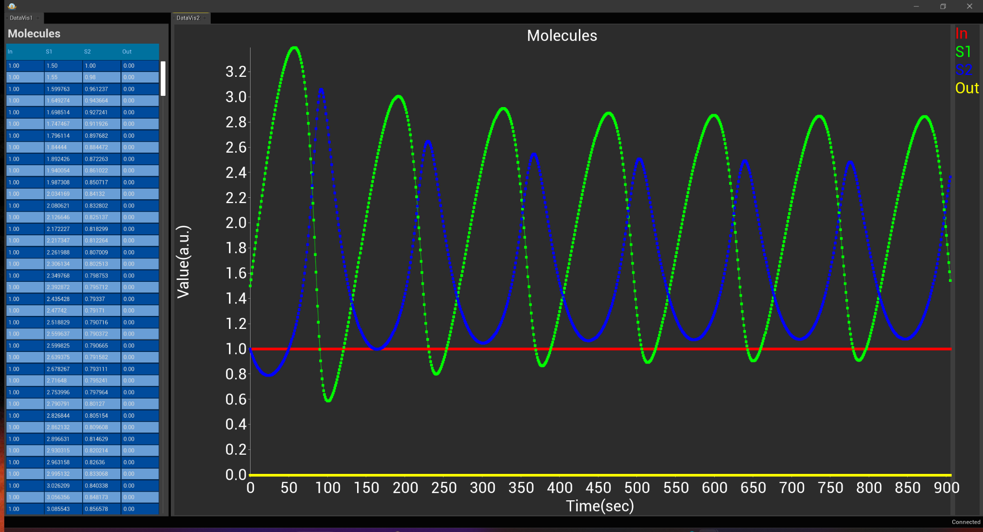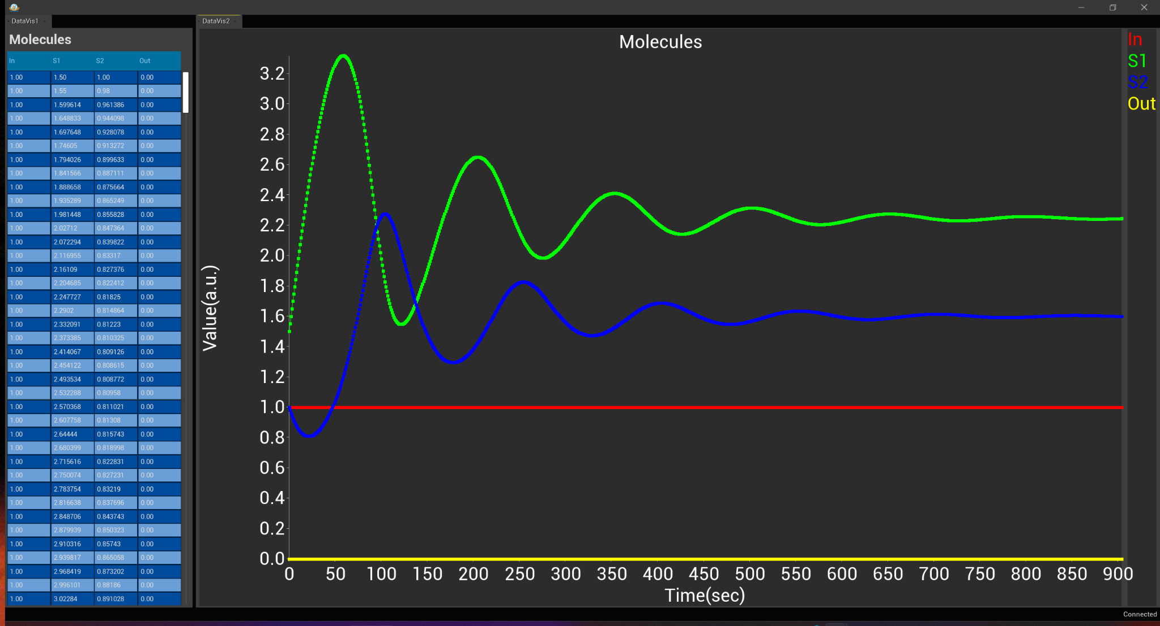(Left) The intended sustained oscillations with nH=2.5

(Right) The unintended damped oscillations with nH=2